Presenting to Customers - VS - Training Customers
NEOWIT – January 14, 2021

How to Create a Numbered Table in Word
# | Step | Image
 | Open word document – existing or new.
 | Click on Insert in the menu bar. | 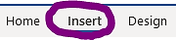
 | Click on Table icon.  Highlight the cells to choose the number of columns and rows for your table. | 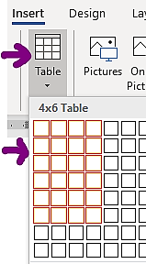
 | Click on Table Tools - Design in the menu bar.
 | Click on the top line of the table to highlight it.
 | Use Shading to choose a background color. | 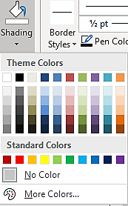
 | Type column headings – apply bold formatting if desired.
 | Click on Table Tools – Layout in the menu bar.  Click Repeat Header Rows, if desired. | 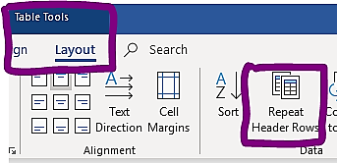
 | Click on Home in the menu bar.
 | Highlight the 1st column below the column headings. | 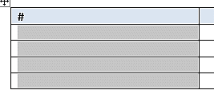
 | Click on Autonumbering in the menu bar. | 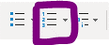  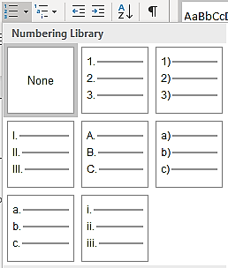
 | Adjust the margins for the automatic tab settings. | 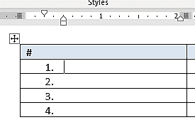
 | Adjust the column width as desired.  The table is now ready for instructions. | 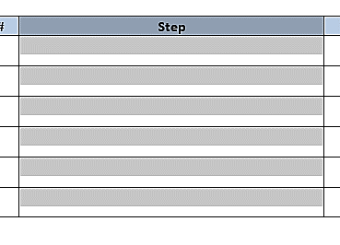

- Format all the images the same – using Picture Tools – Format
- Corrections allows you to darken, brighten the image.
- Picture Border allows you to add a border – style and width of line.
- I prefer to (1) format my images centered in the column and (2) include a blank line above and below the image which I set to a font size of 6.

Numbered Table Template
# | Step | Image

